|  |
| --- |
|  |
| The Documentation |
| [Type the document subtitle] |
|  |
| **[Your Name]** |
| **[Pick the date]** |

[Type the abstract of the document here. The abstract is typically a short summary of the contents of the document. Type the abstract of the document here. The abstract is typically a short summary of the contents of the document.]

Table of Contents

[To update the table of contents, right click the message below and select Update Field (F9 on PC, ⌥⌘U on Mac).]

**No table of contents entries found.**

1. Pages
   1. Page Tree

Admin Console  
 User Access Management  
 User List  
 Add User  
 Edit User  
 Function List  
 Edit Function  
 Group List  
 Edit Group  
 User Works  
 User Mapping  
 User Mapping 2  
 Customer Maintenance  
 Profile Enquiry  
 Contact Info  
 Policies  
 Transaction History  
 Summary Reports  
 Statical Reports  
 Date range picker  
 Customer Range  
 End of Day Reports  
 Notice Message Management  
 Notice List  
 Edit Notice  
 Preview Notice  
 Audit Log

* 1. Admin Console
     1. User Interface

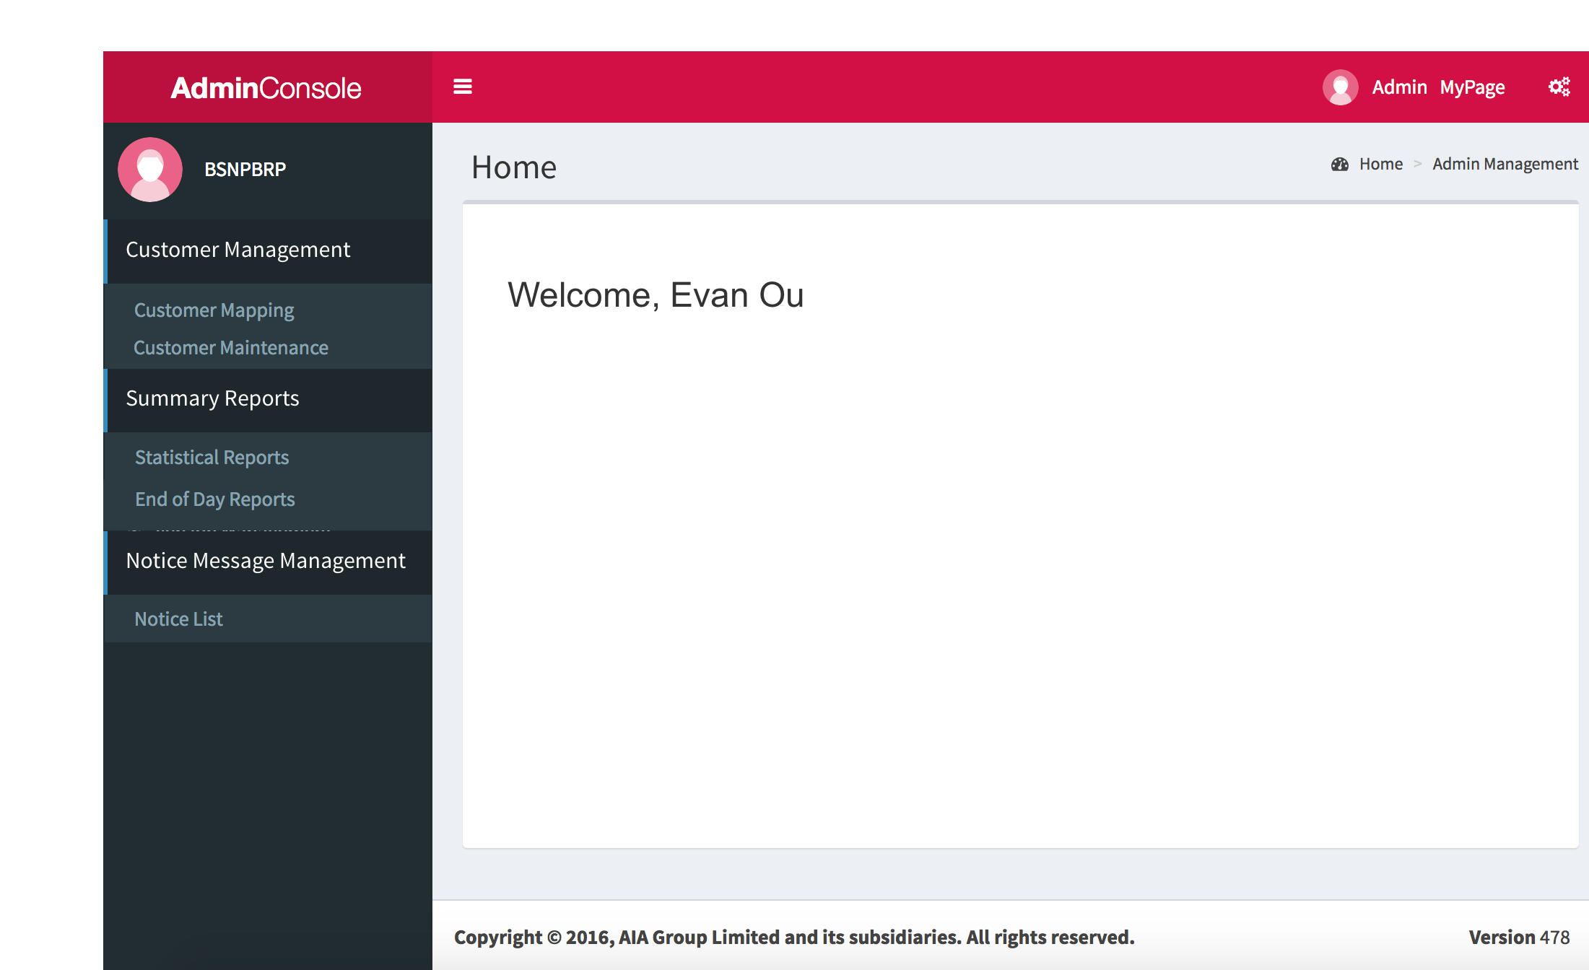

* 1. User Access Management
  2. User List
     1. User Interface

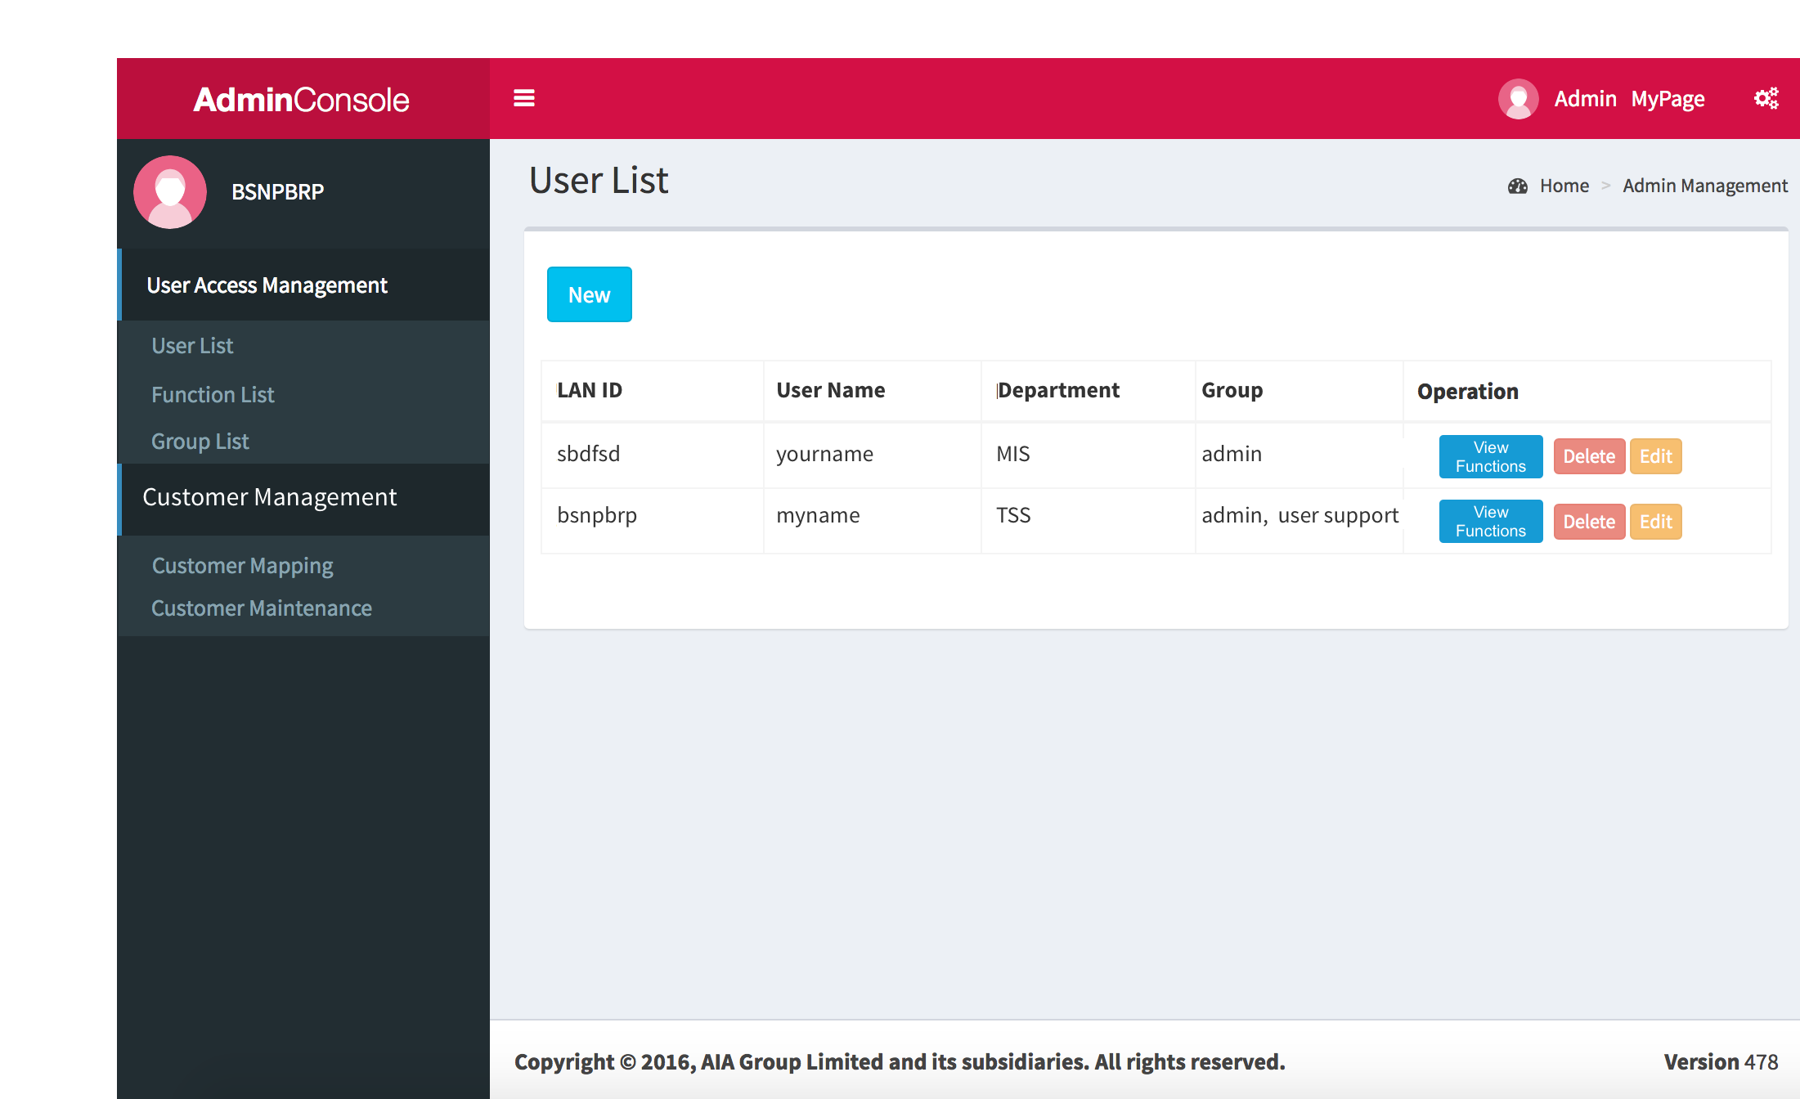

* 1. Add User
     1. User Interface

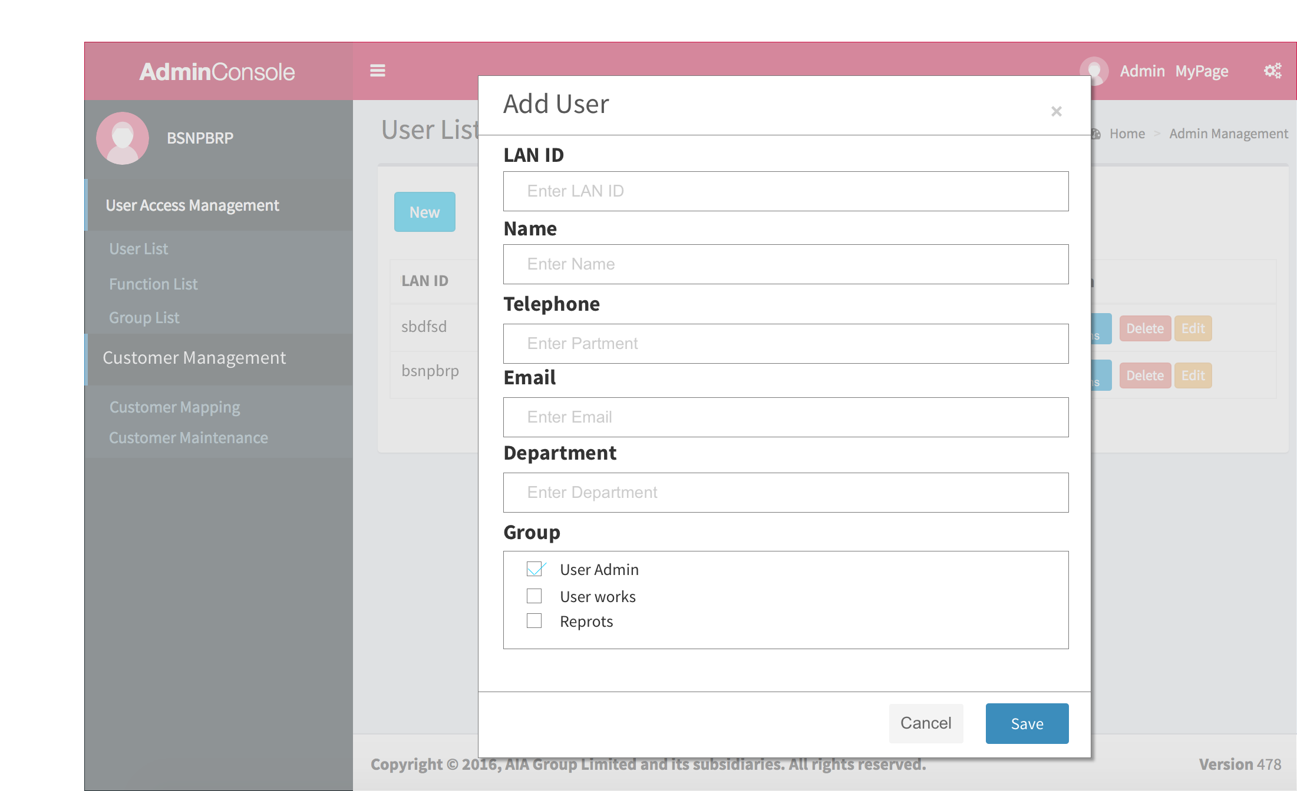

* 1. Edit User
     1. User Interface

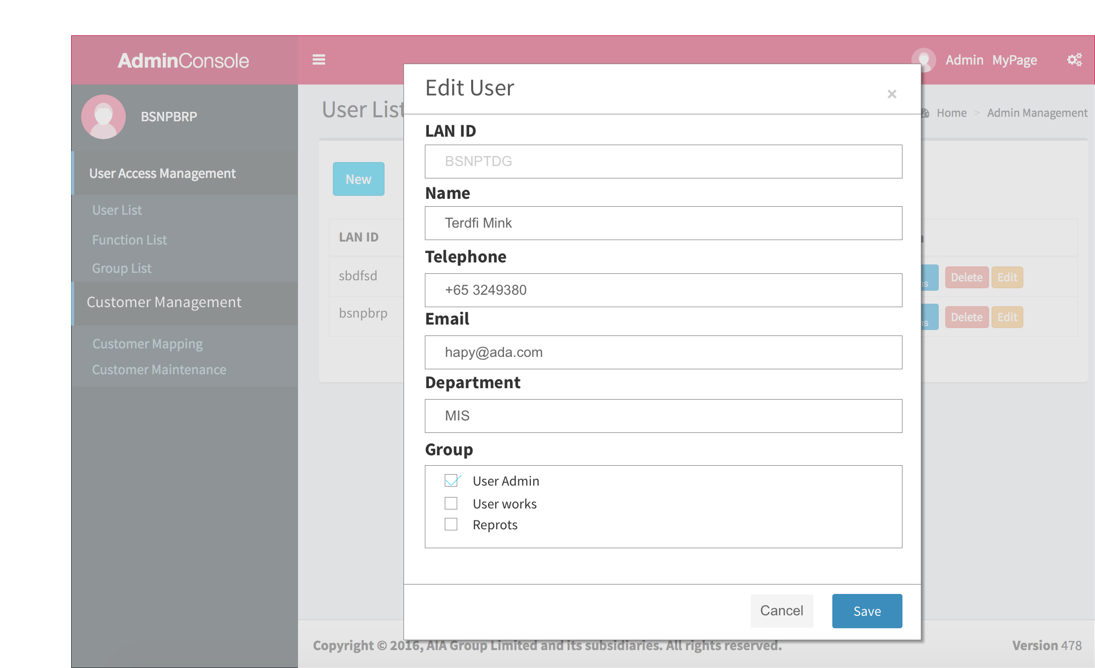

* 1. Function List
     1. User Interface

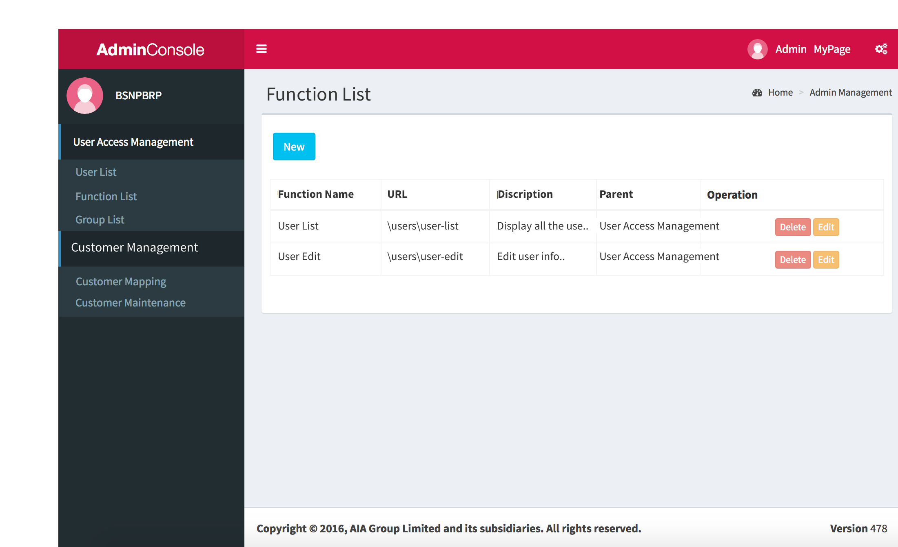

* 1. Edit Function
     1. User Interface

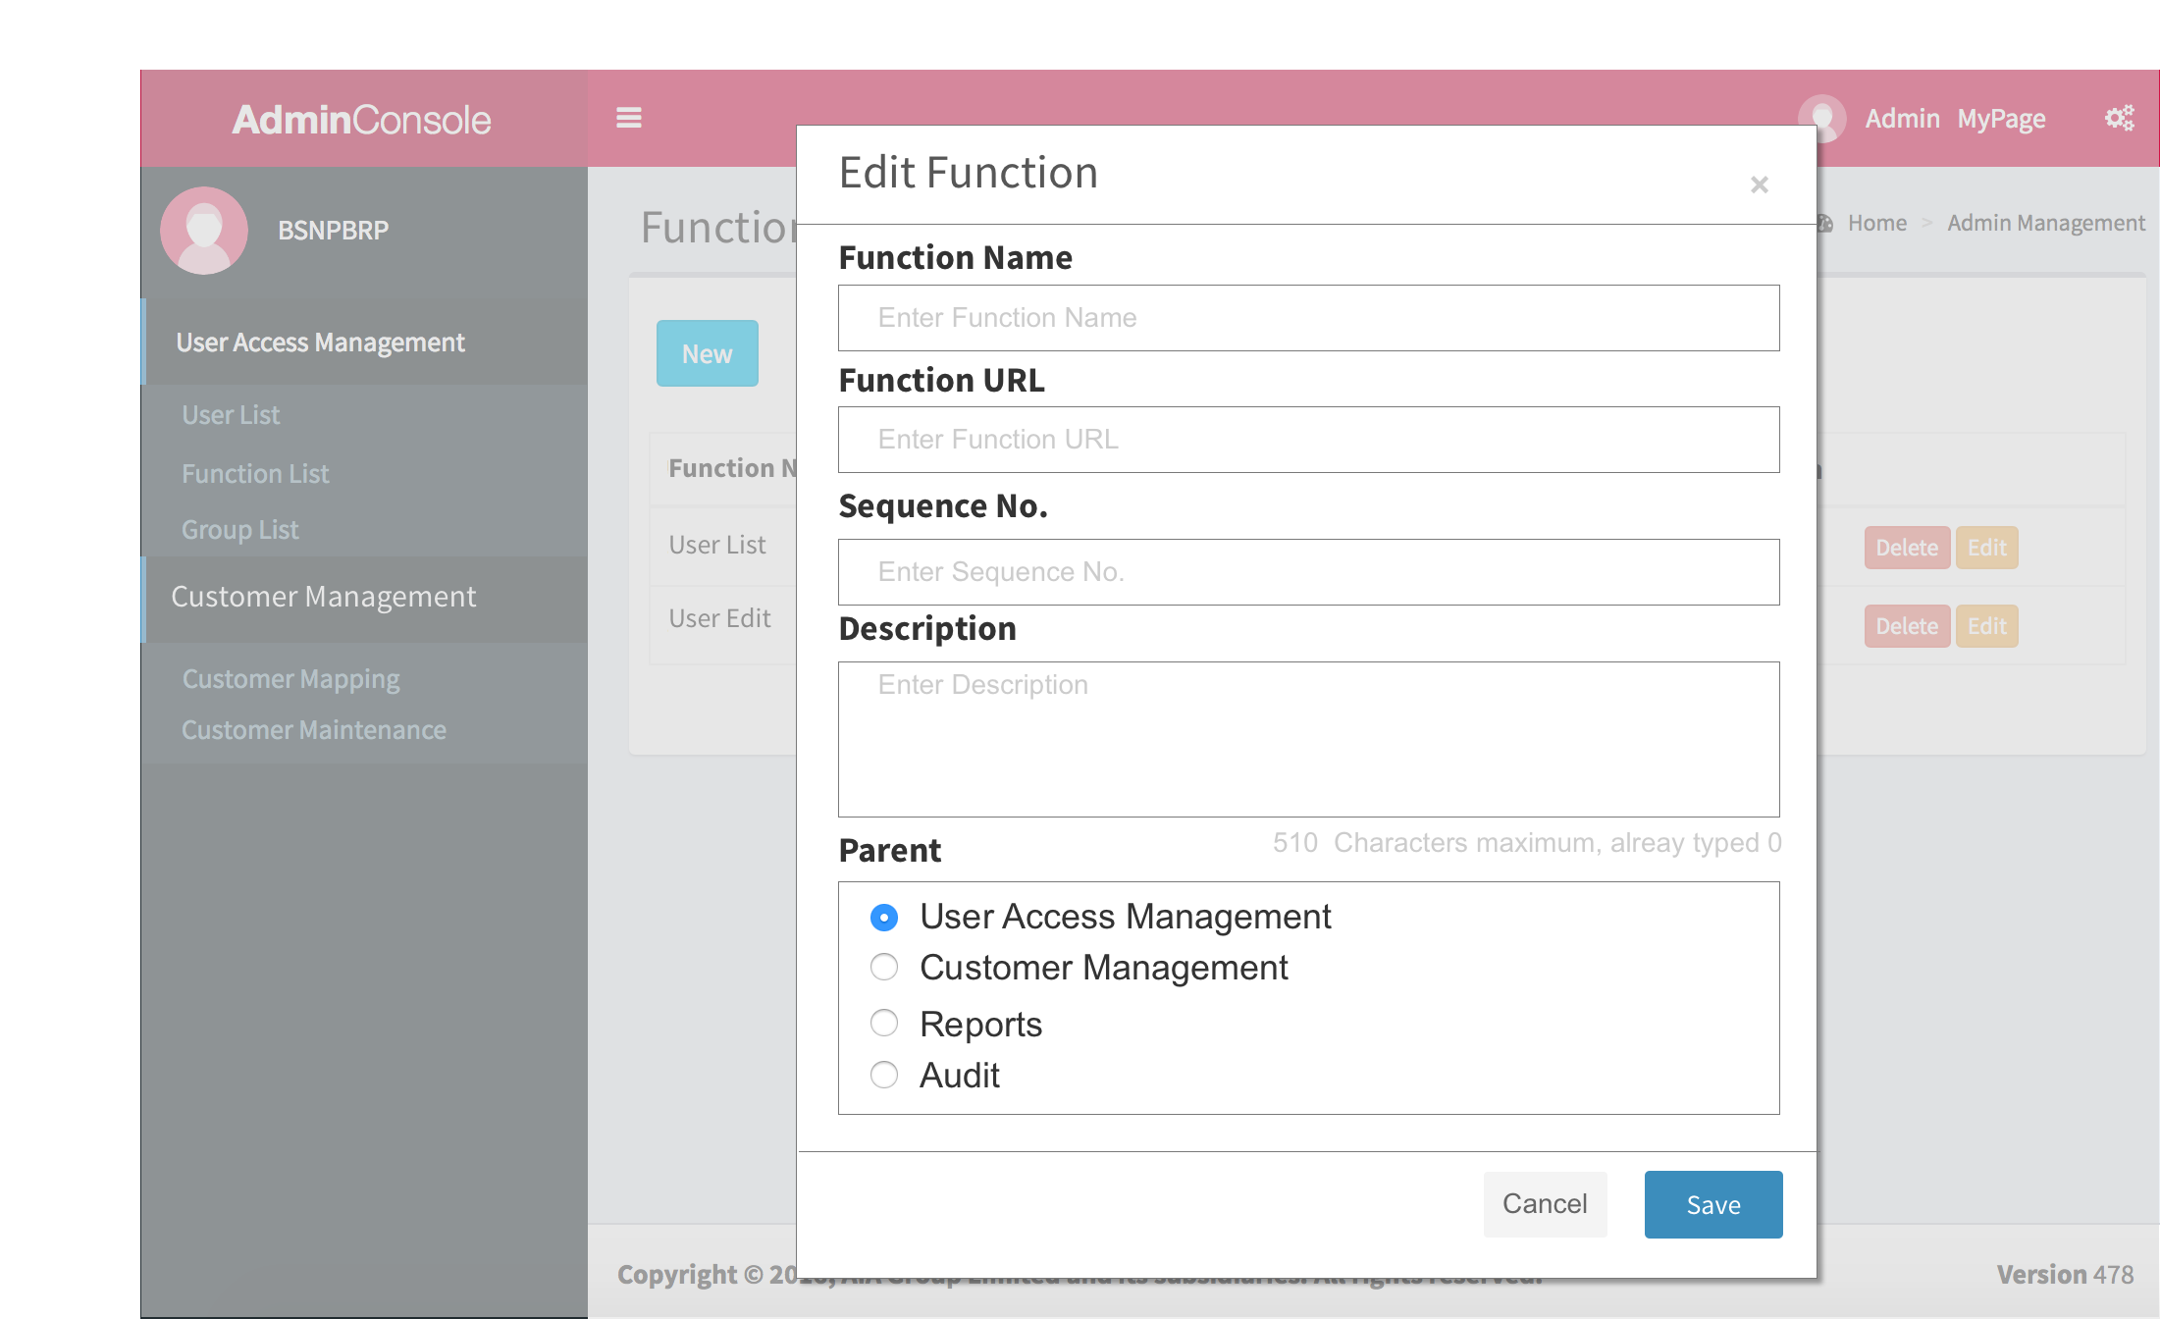

* 1. Group List
     1. User Interface

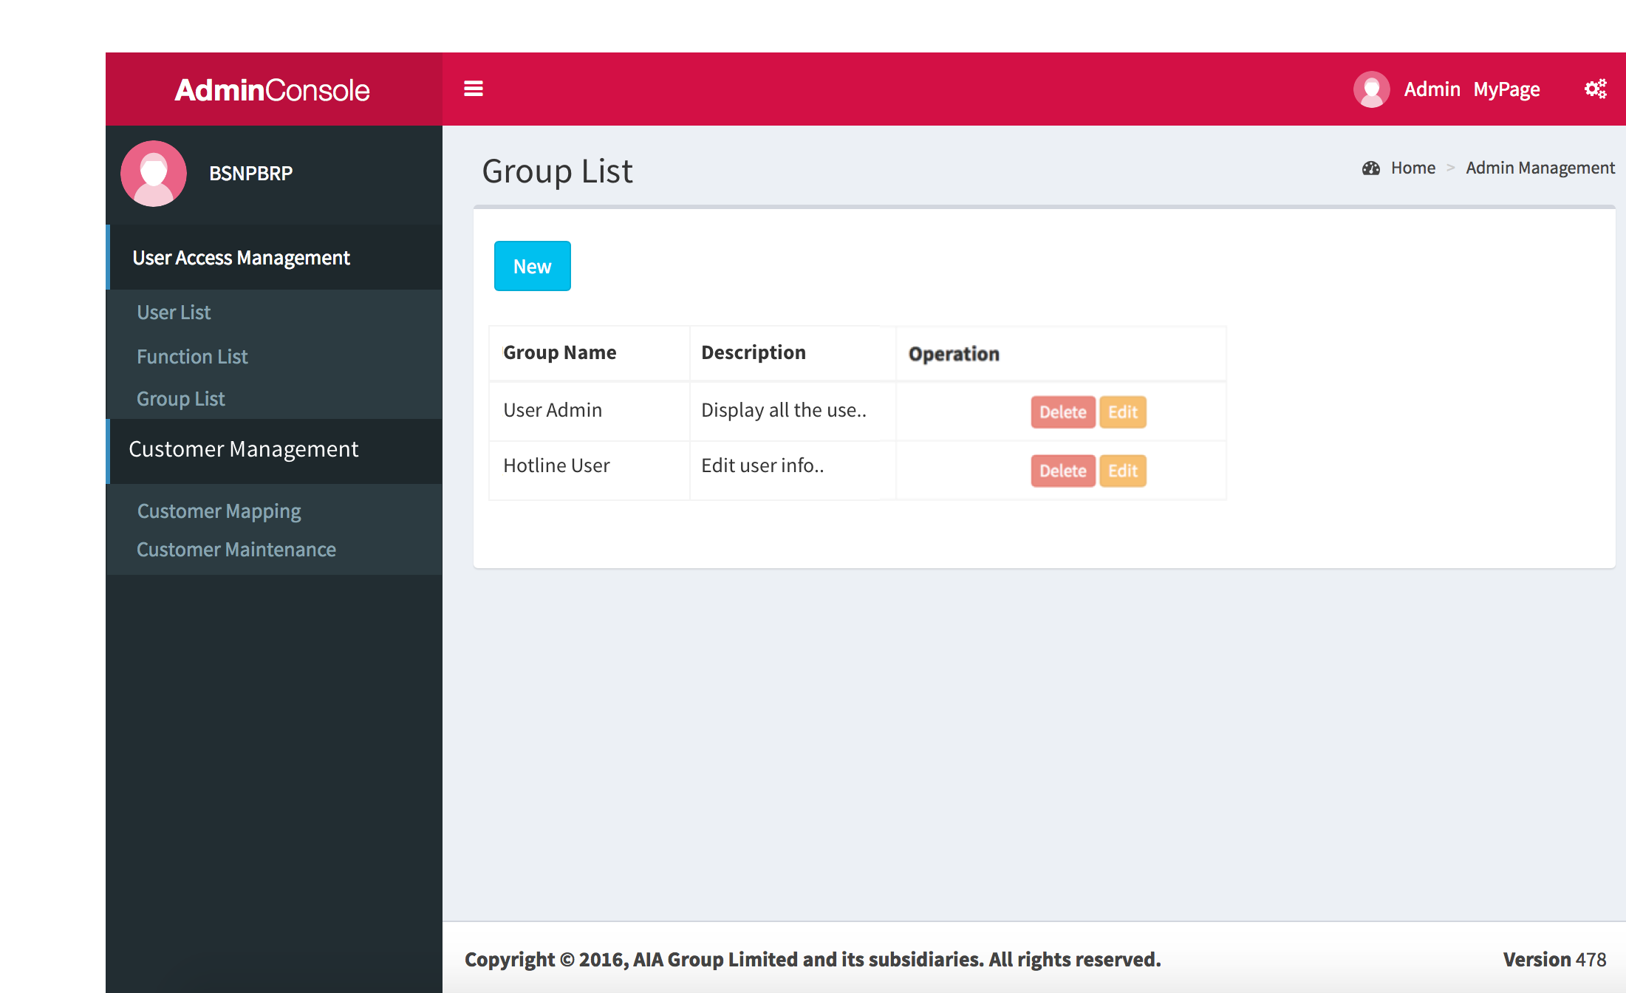

* 1. Edit Group
     1. User Interface

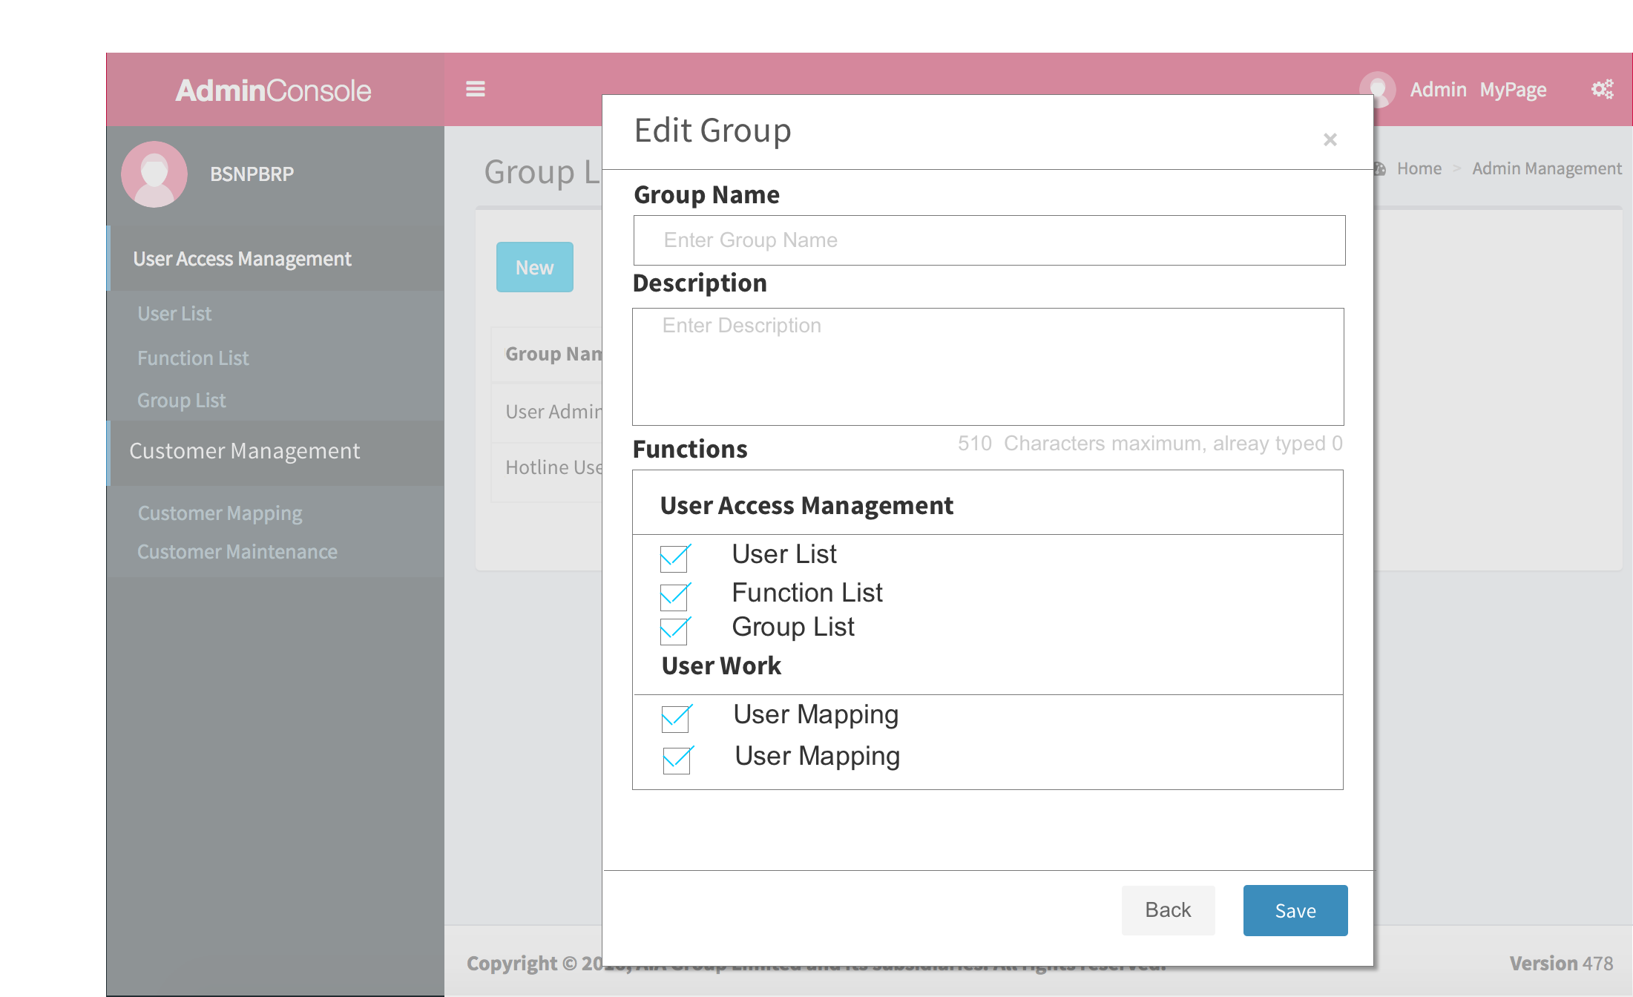

* 1. User Works
  2. User Mapping
     1. User Interface

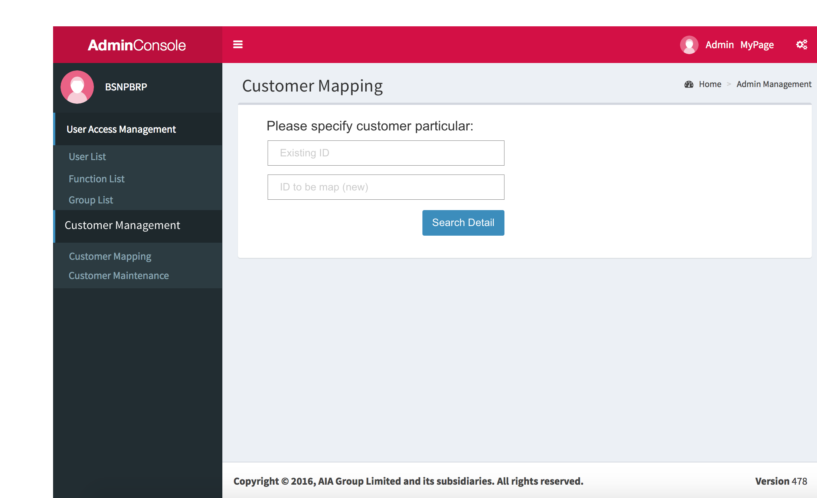

* 1. User Mapping 2
     1. User Interface

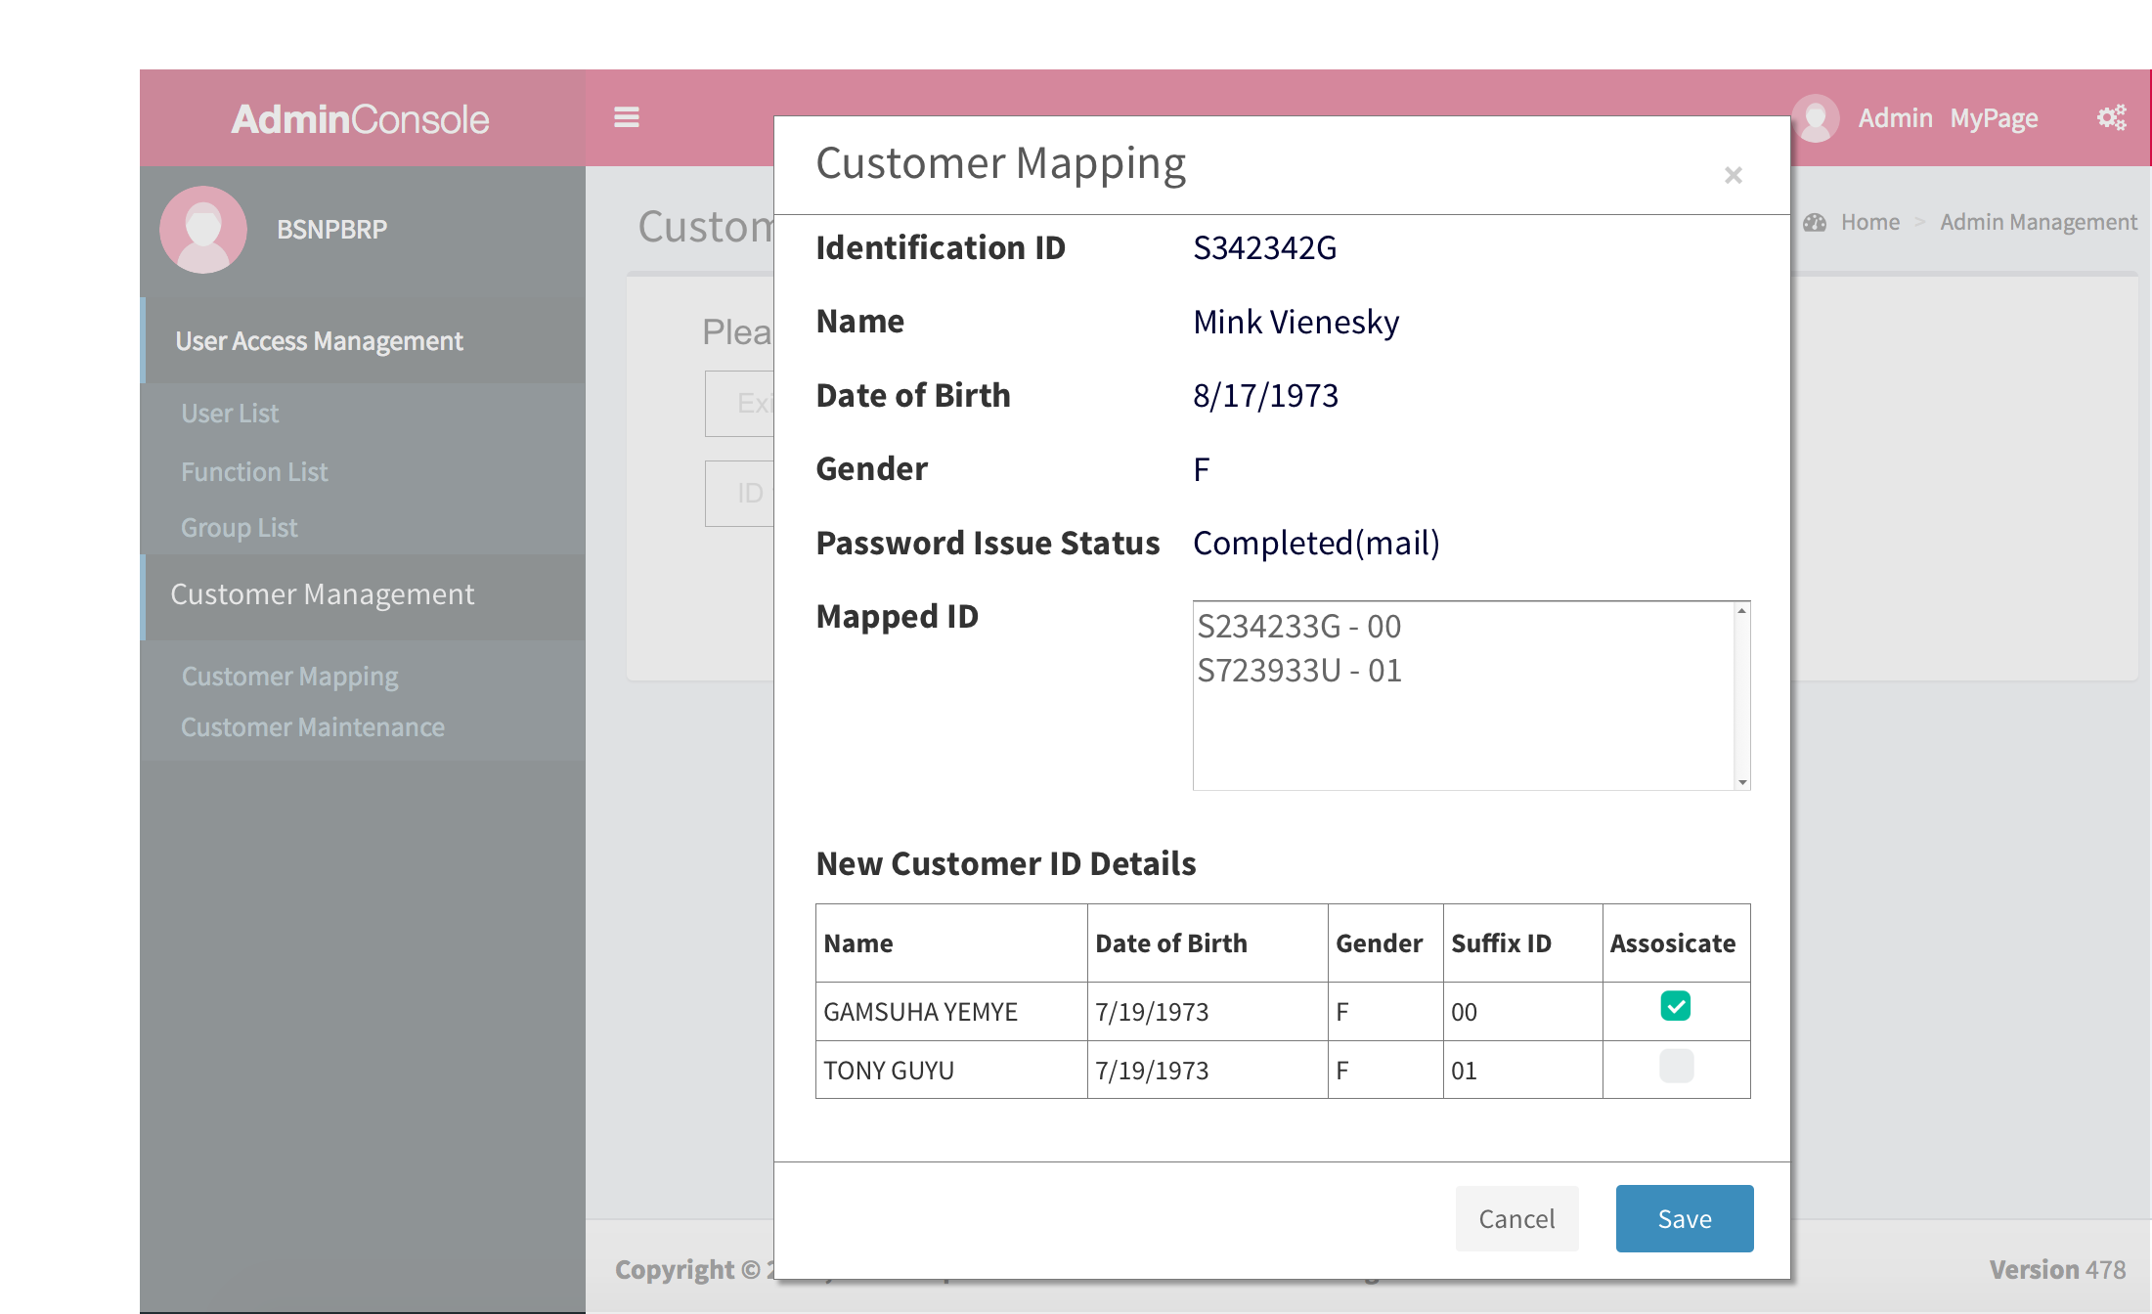

* 1. Customer Maintenance
     1. User Interface

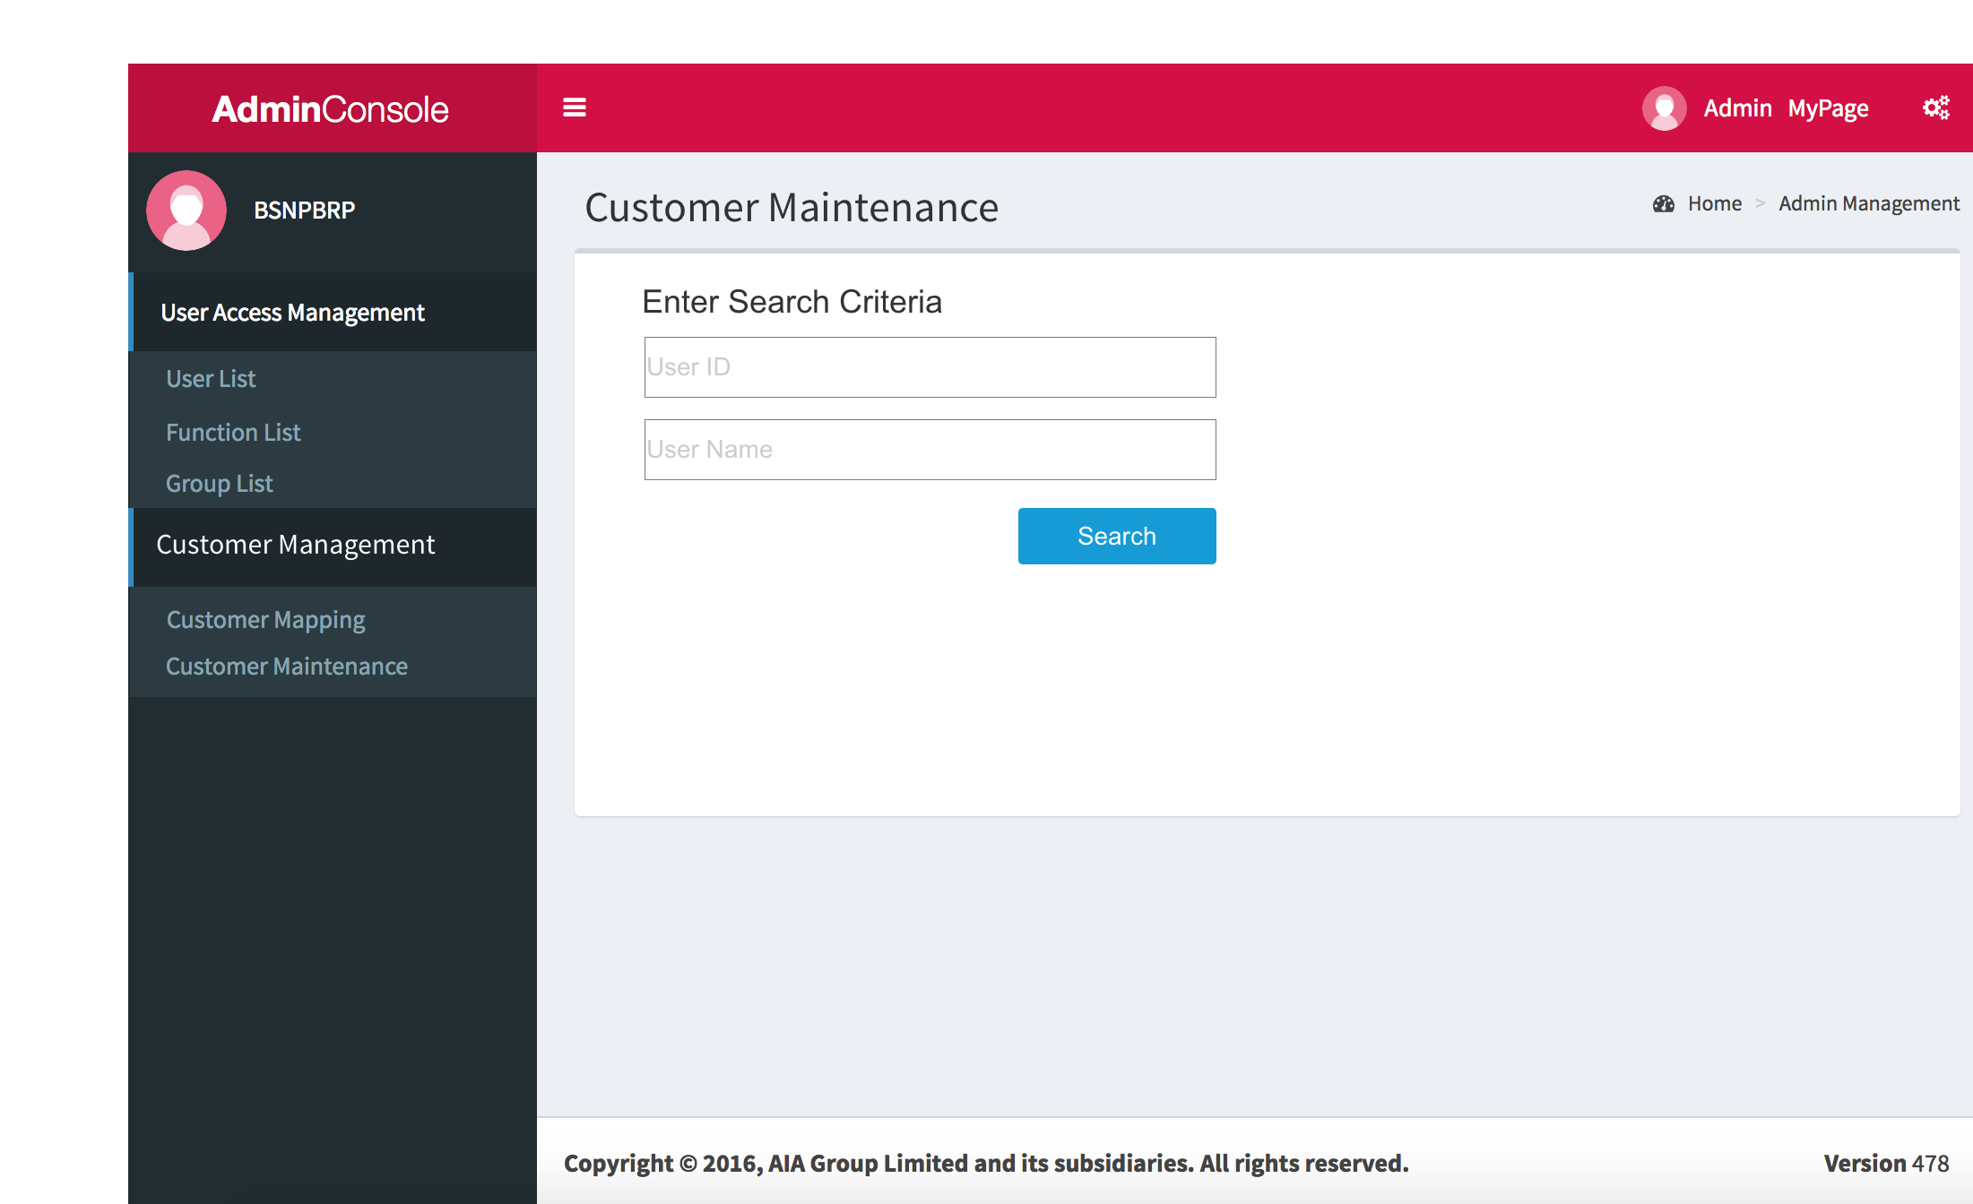

* 1. Profile Enquiry
     1. User Interface

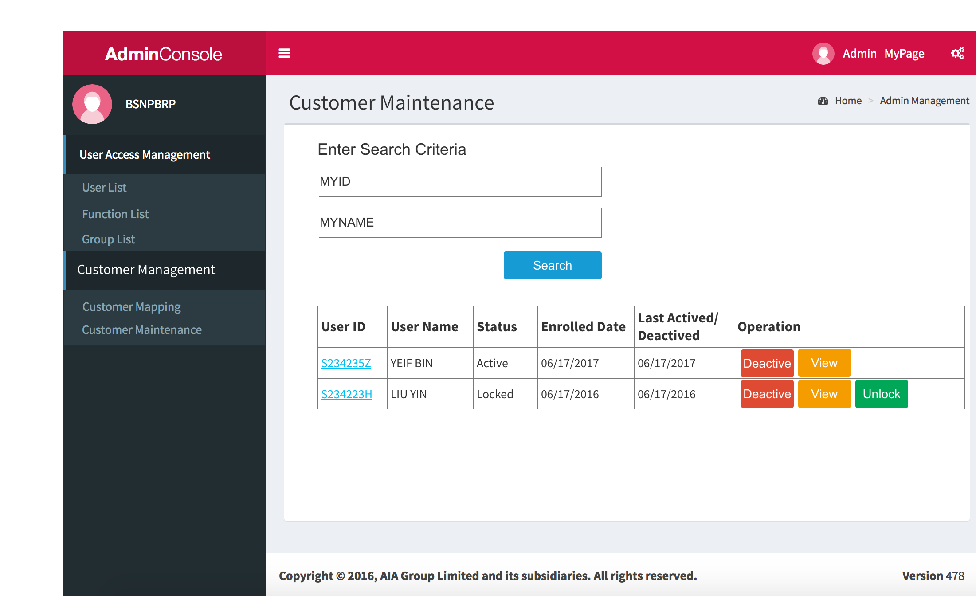

* 1. Contact Info
     1. User Interface

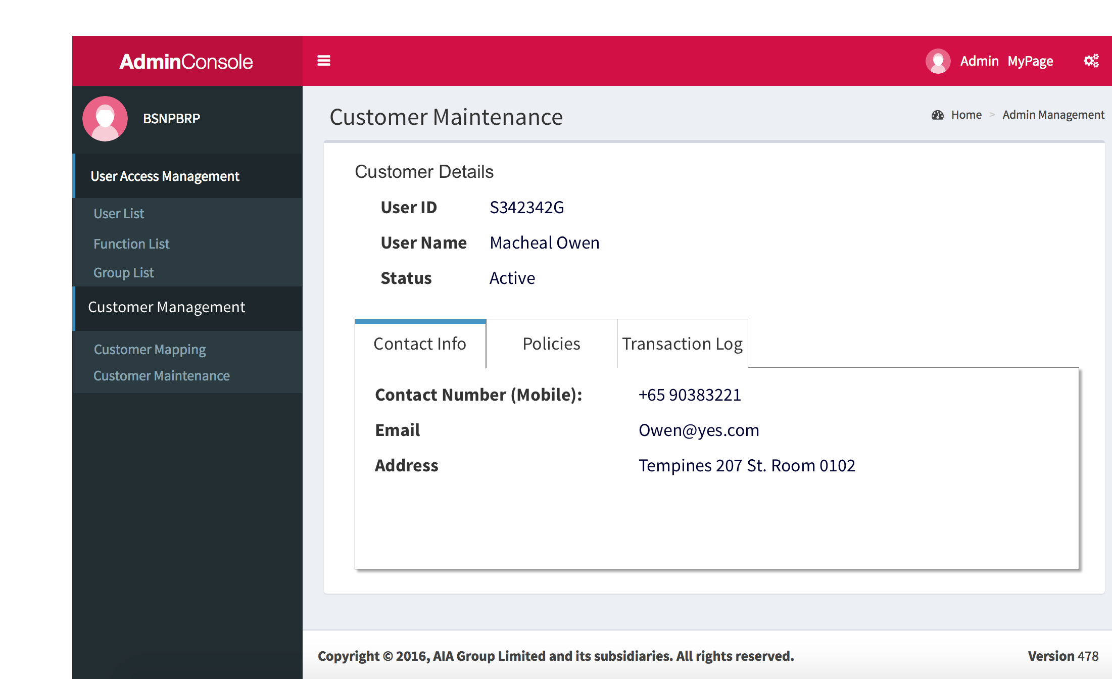

* 1. Policies
     1. User Interface

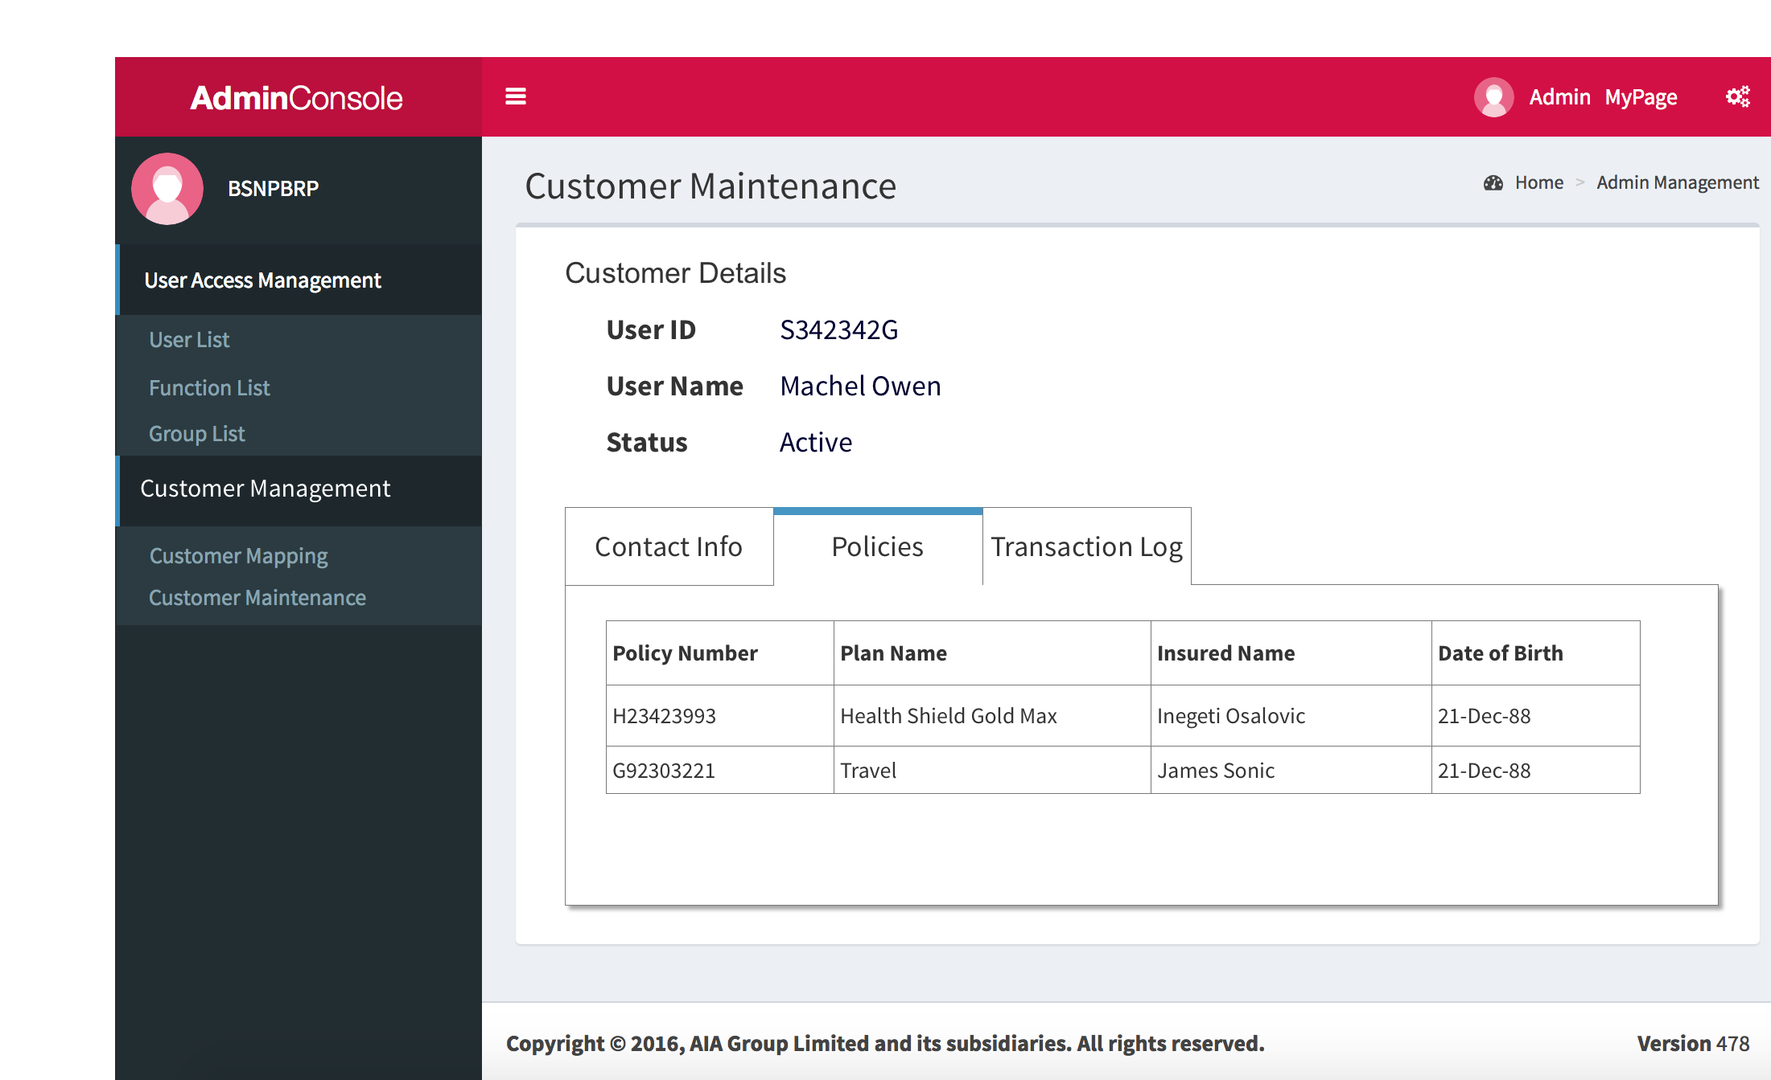

* 1. Transaction History
     1. User Interface

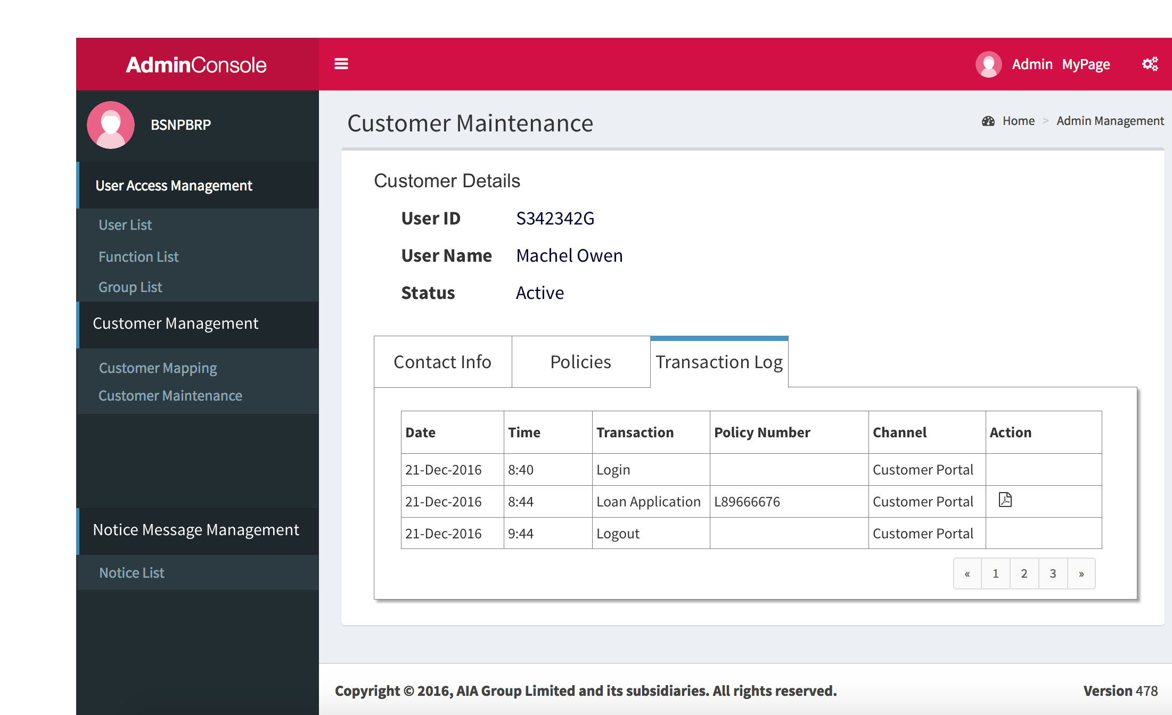

* 1. Summary Reports
  2. Statical Reports
     1. User Interface

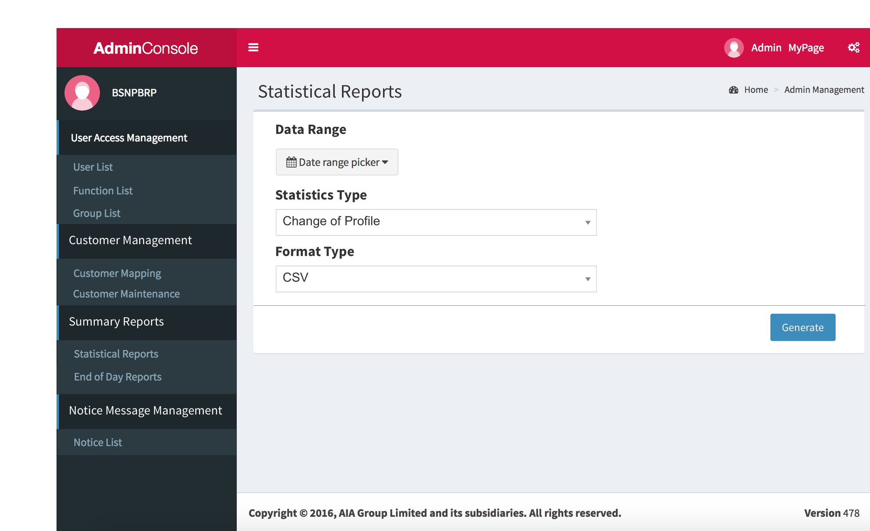

* 1. Date range picker
     1. User Interface

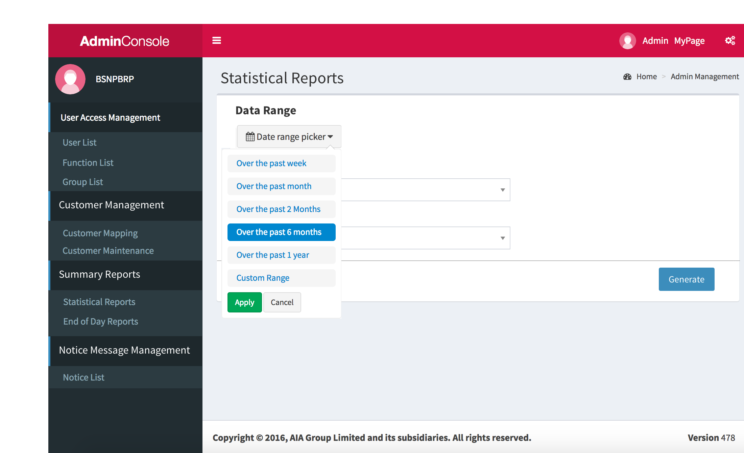

* 1. Customer Range
     1. User Interface

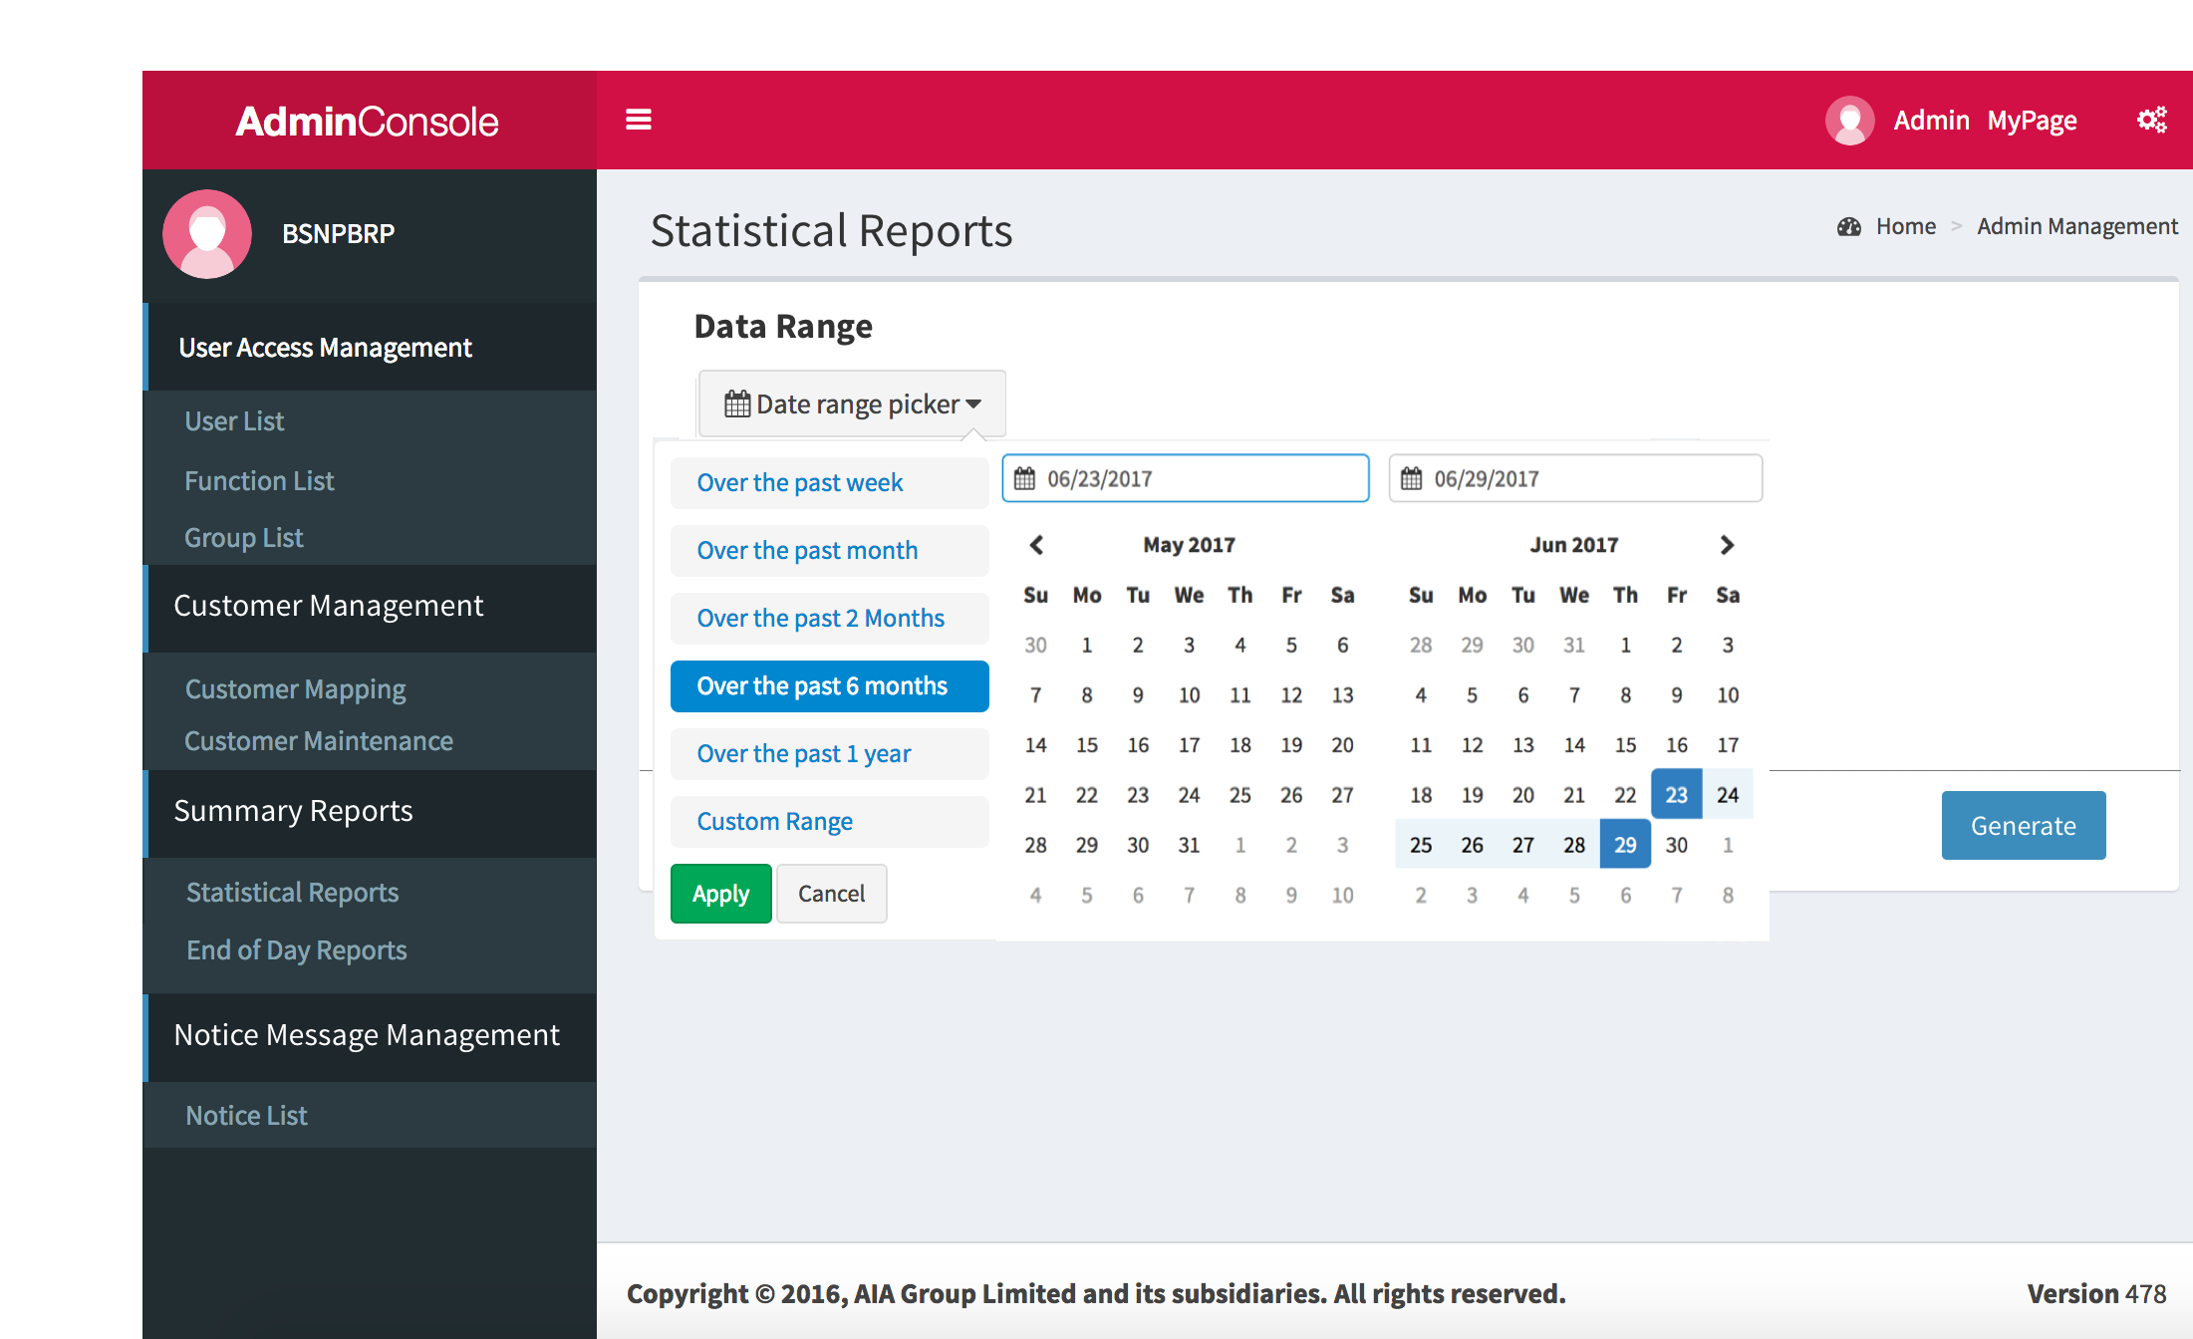

* 1. End of Day Reports
     1. User Interface

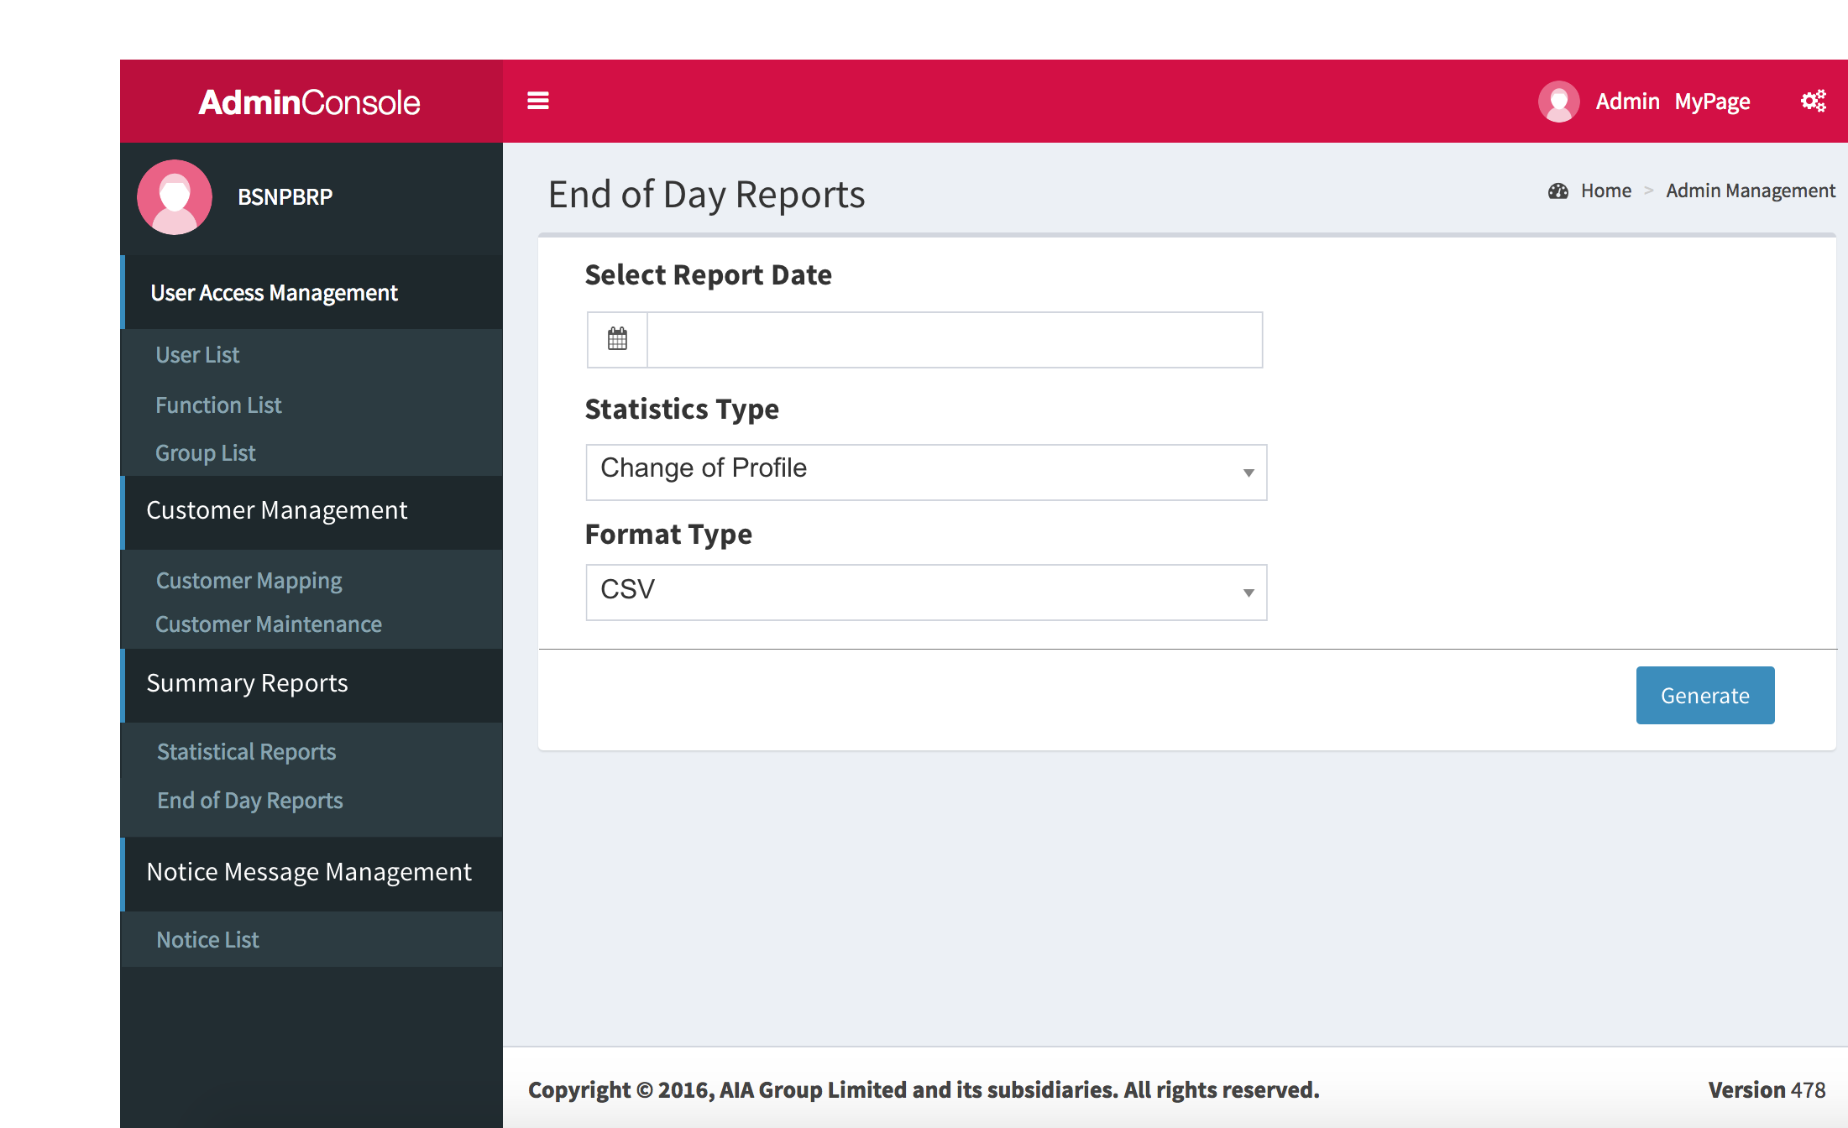

* 1. Notice Message Management
  2. Notice List
     1. User Interface

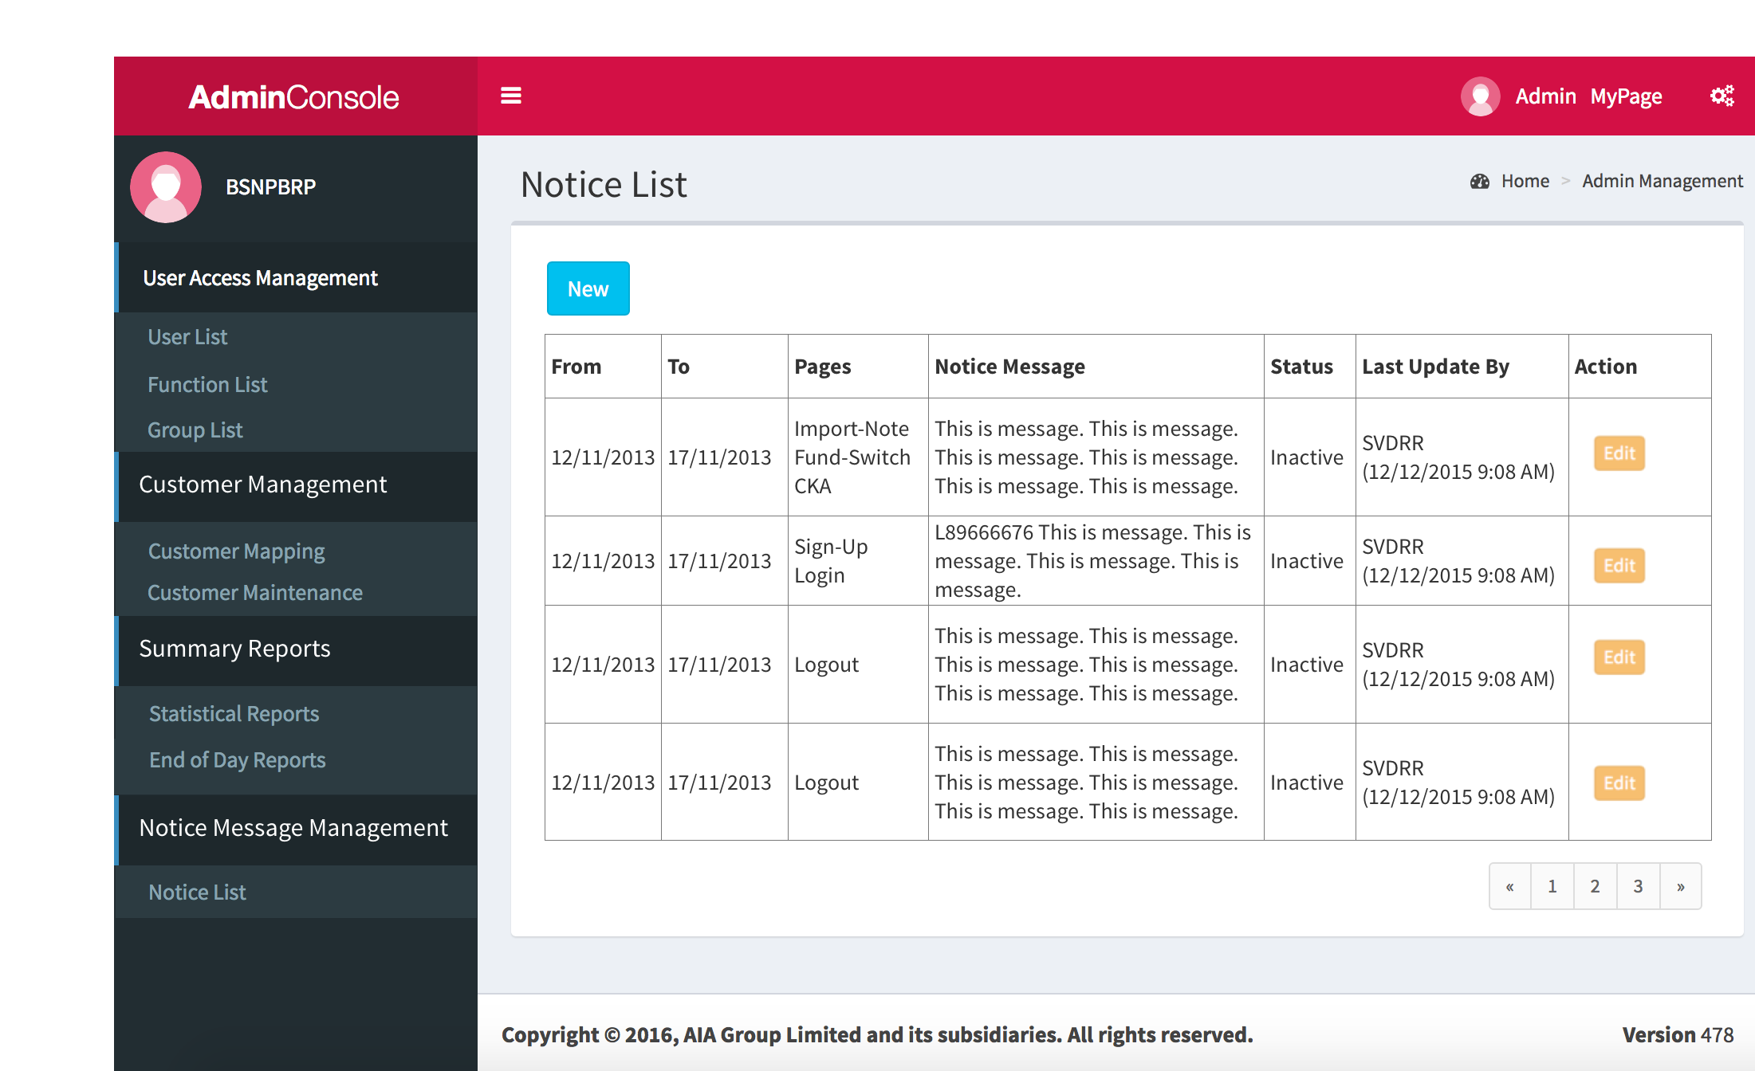

* 1. Edit Notice
     1. User Interface

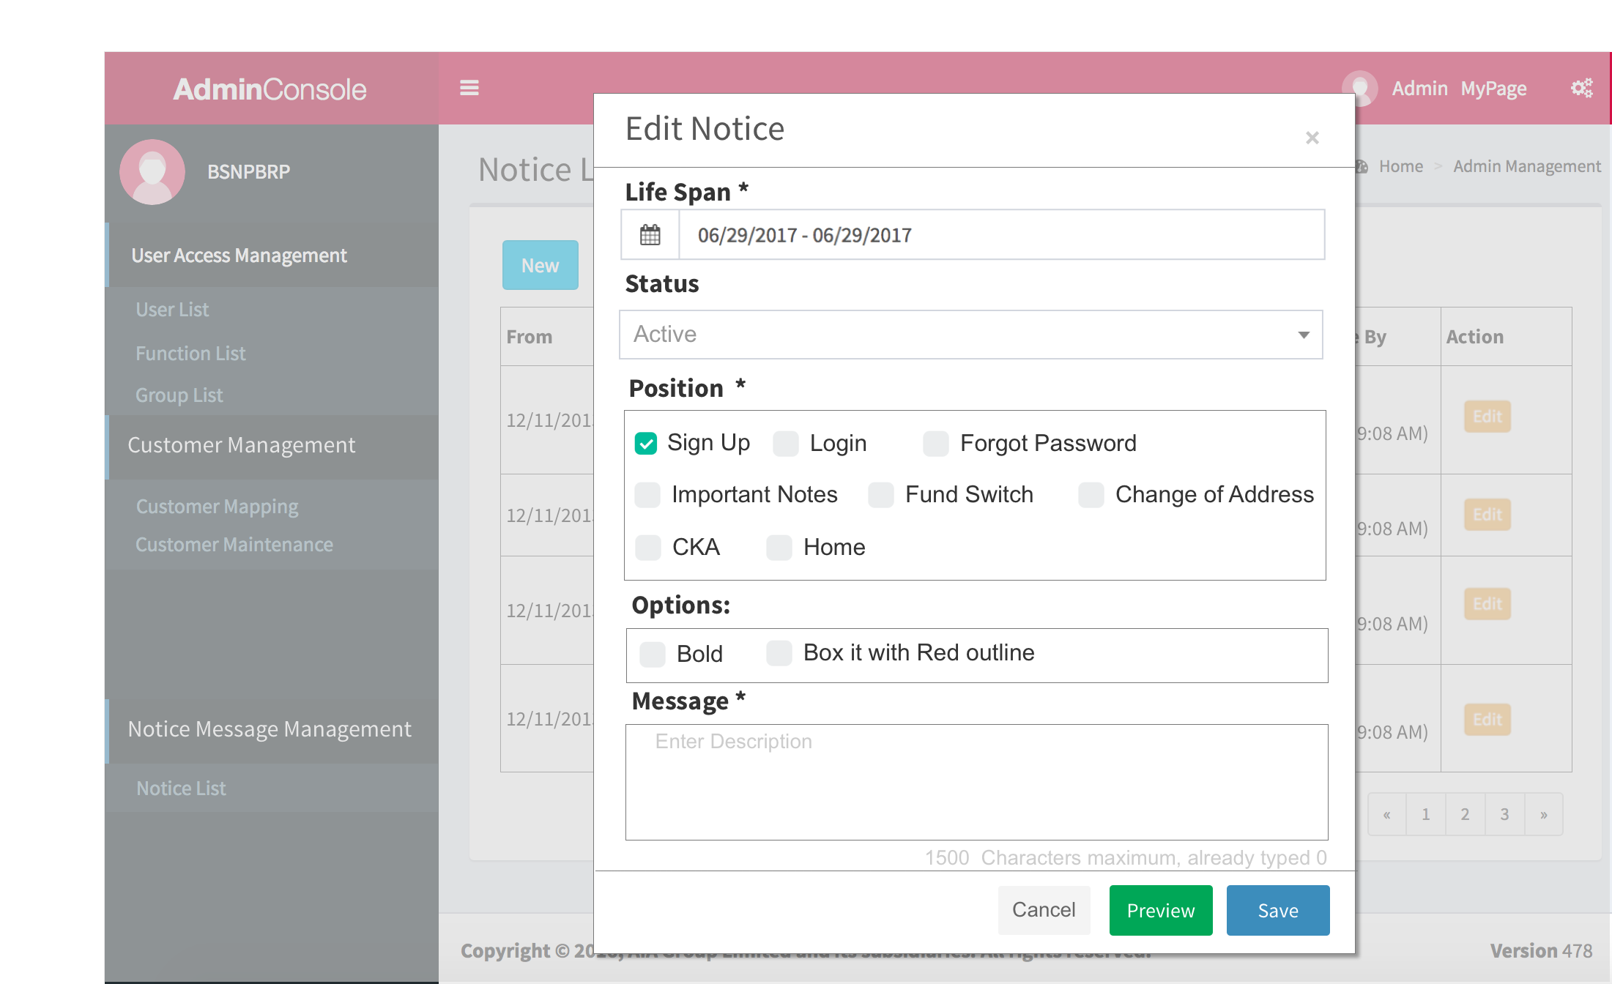

* 1. Preview Notice
     1. User Interface

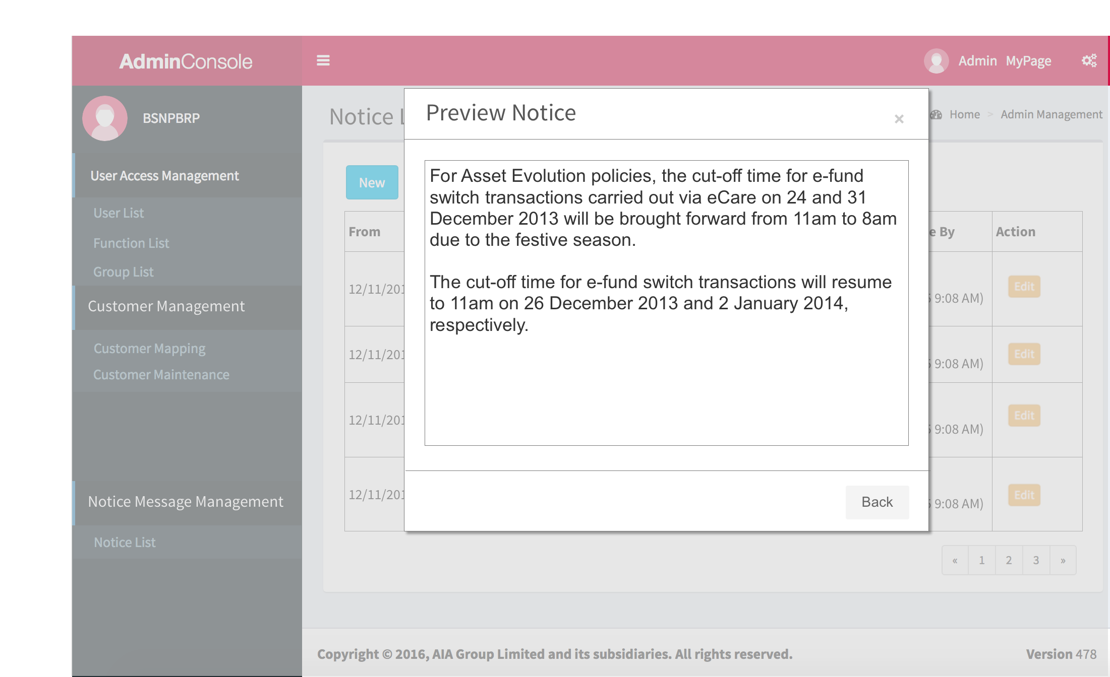

* 1. Audit Log
     1. User Interface

